**Method Statement**

For memorial testing and repairs at Brackley Road Cemetery, Buckingham, MK18 1JA.

**Background**

As the burial authority Buckingham Town Council has Responsibility for the safety (duty of Care) within the Brackley Road Cemetery under the Health and Safety at work Act 1974 and the Occupiers Liability Act 1957 to ensure that as far as reasonably practicable the site is maintained in a safe condition.

Over the last 30 years eight people in the UK have been killed when a memorial has fallen on them, this risk is relatively low considering the number of visitors to burial grounds. But as a part of the managing of the risk in the cemetery a simple process to assess the risks posed in the cemetery and manage the outcome is to be undertaken.

Current guidance and best practices will be followed (see the ICCM Memorial Management Policy 2019)

**Description of Work**

It is recommended by the Institute of Cemetery and Cremation Management that memorials should be tested every 5 years this can be split into a 5 year cycle and done on a yearly basis to spread the financial burden on the managing authority of the cemetery. The town councils aim is to test and make safe.

**Method of Working**

1. **Raising Awareness** – Due to the sensitivity of undertaking any work in the cemetery, before any testing is carried out, Buckingham Town Council will publicise the fact that the inspections are being carried out through press releases, public notices at the cemetery and on the Town Council’s Web-site. Informing the public why and how the testing and making safe is being carried out.
2. **Testing** – Due to the large number of Memorials in the cemetery (estimated 3000) an annual program of inspections is required; a minimum of 20% of memorials must be inspected every year so all memorials can be tested within 5 years. Following a risk assessment of the cemetery the areas closest to the main access paths will be assessed first due to the higher potential of an injury occurring. The 5 assessment criteria used for the visual assessment of the cemetery are listed below (recommended by the HSE).

**Identify the hazard** – e.g. a potentially unstable memorial.

**Identify who might be harmed and how** – these might be employees, contractors, volunteers or members of the public who may be hit by a falling memorial.

**Evaluate the risk** of a memorial falling and harming someone, and decide on the precautions needed to control this risk.

**Record the significant findings** of the risk assessment and take steps to implement the precautions needed.

**Review** the risk assessment periodically to see if anything has changed and update it if necessary.

Memorials under 1.5m high will be visually and physically tested by trained Town Council staff.

Memorials over 1.5m tall will be safety tested by a specialist qualified surveyor.

Memorials will then be visually assessed bearing in mind issues including – size, Age, Are the joints intact, Is the memorial Leaning ? Are there any Cracks present? etc. If the above indicates there may be a problem the next step is the hand test. Current advice is that the blanket use of force measuring equipment is not used on all memorials. The hand test of the memorial will be taken by standing to one side of the memorial and applying firm and steady pressure in different directions to determine if the headstone is loose. In some circumstances following a hand test the memorial may be determined to be a high risk a decision is then required as to how to deal with the risk. This may be as simple as erecting signage to warn cemetery users of the danger sectioning off an area or temporally supporting a memorial the last resort if nothing else is possible to make the memorial safe is to temporarily lay the memorial down until it can be repaired.

1. **Notifying Grave owners** – Buckingham Town Council will advise grave owners when memorials are found unsafe, the problem however is that finding some of the owners may be difficult. It is recommended that all owners of graves less than 30 years will attempted to be contacted in writing as well as there being further publicity through local press and notices in the cemetery.
2. **Making safe of memorials** – After temporally making dangerous memorials safe steps to making permanent repairs will be made as soon as possible, this is to minimise the distress and upset to mourners as well as reducing the impact on the appearance of the Cemetery. Where the Deed holder can be found the legal responsibility lies with them to make the memorial safe and informed that repairs must meet NAMM or BRAMM regulations, further publicity at this stage will also be required to try and locate any Deed holders or relatives. A lot of the memorials in question are well over 100 years old, it is anticipated that the vast majority of these the deed holder or relatives are unobtainable and the memorials will be considered for repair by the Town Council on a case by case basis other suitable methods for making the memorial safe will be considered but laying memorials flat on the ground will be avoided if at all possible. The Town Council will employ the use of a professional, fully accredited memorial mason who specialises in the repairs of un-safe memorials to undertake the repairs in the cemetery. The contractor has specialist lifting equipment for the safe moving of larger memorials. All repairs will meet with BRAMM Guidelines and adhere to the relevant BS codes. The contractor will provide evidence of suitable insurance and have undertaken risk assessments for the work to be undertaken. The type of repair will depend on the memorial; size, type, stone etc.
3. **Inspection records** - Accurate records will be maintained so a yearly program of inspections can be carried out. Below is what information will be recorded as a part of the visual and hand-test inspection.

|  |  |  |  |  |  |  |  |  |  |  |  |  |
| --- | --- | --- | --- | --- | --- | --- | --- | --- | --- | --- | --- | --- |
|  | Location |  |  | Details |  |  | Memorial Condition | | | Action |  |  |
| Insp. Ref. No. | Section | Plot No. | Size - (below 1m = A, 1m-2.5 = B, over 2.5m = C) | Type of Memorial (head/cross) | Material - (Hard/soft stone) | Cracks | Leaning | Joints in tact | Is memorial rocking | What action Required - | Priority of Action -1,2 or 3. | Pic. (Y/N) |

**Sequence of operations**

Publicity before testing (no less than 2 weeks prior to inspections).

Safety testing of memorials.

Notification of Grave owners to make the memorial safe.

Further publicity to locate any deed holders or relatives.

Making safe of memorials.

**Supervision**

The initial testing will be carried out by Buckingham Town Council staff and any specialist testing will be sought as required.

The repairs will be carried out by a specialist BRAMM approved Memorial Mason and closely monitored by Town council staff.

**Monitoring**

Re-inspection of the repaired memorials will be carried out by Buckingham Town Council staff. This will then be a part of an ongoing assessment of memorial safety in the Cemetery on a yearly basis. All memorials will be inspected on a 5 yearly basis.

Insert 5 year plan and which areas are going to be tested when …

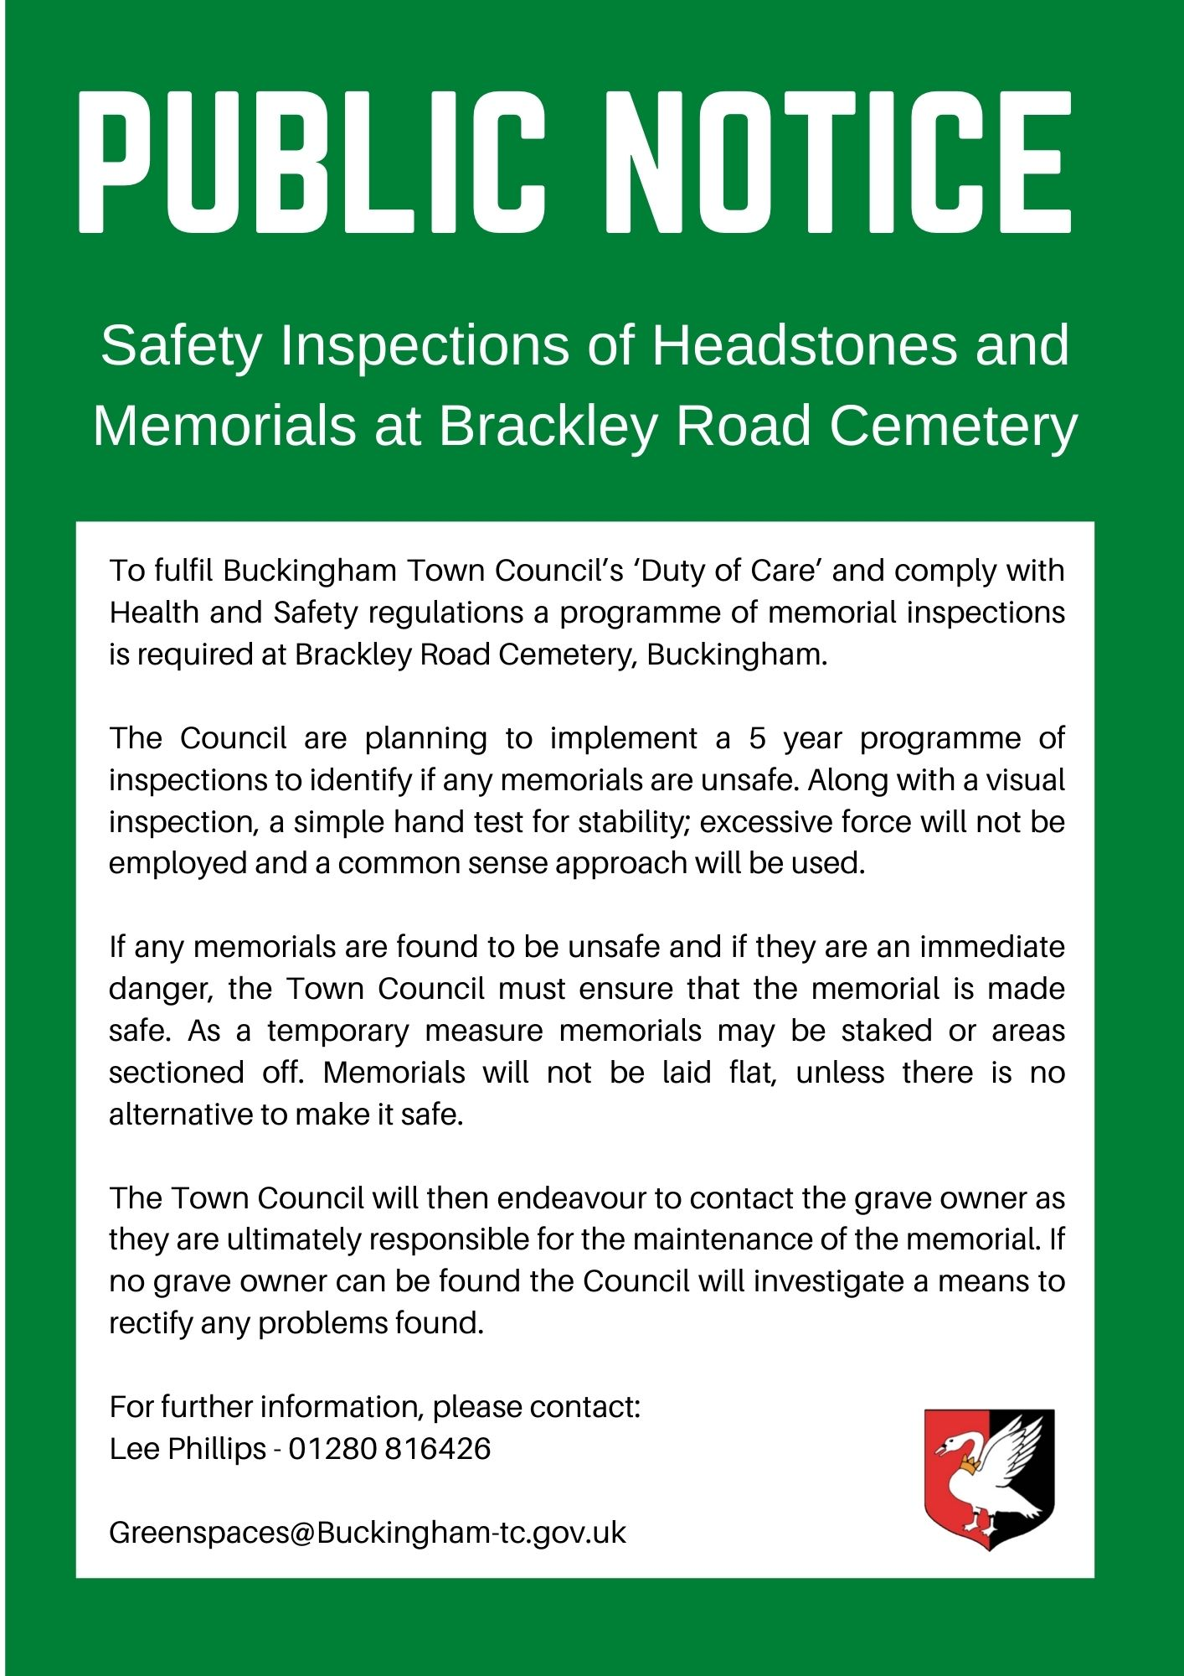

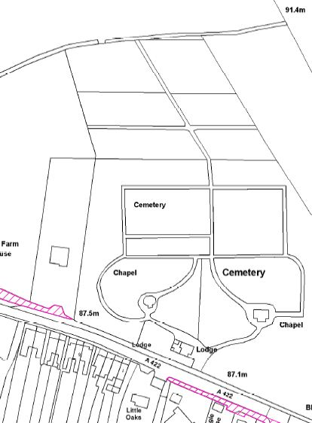

Area in circled in red is consecrated ground.