Buckingham Town Council
Annual Town Meeting (ATM)
Feedback Report 2018
Purpose
This report provides a summary of Buckingham Town Council’s Annual Town Meetings held online between 5-9th March 2018 and in person on Wednesday 21st March 2018 at Buckingham Community Centre.
The purpose of the Annual Town Meetings was to reflect on the key successes and challenges of Buckingham Town Council and its partners (Thames Valley Police, Buckinghamshire County Council, Aylesbury District Council and Buckingham University) throughout the year.
This year The Town Council tried a new format and hosted a virtual ATM meeting on the Town Council’s Facebook page. Residents were invited, via a variety of media, to post questions or comment under discussion topics and Officers were encouraged to respond. The ATM of the 21st March was chaired by the Town Mayor and run in an Open Space format.
ATM Attendance
In previous years the ATMs have not been well attended with over half the audience comprising Town Councillors and Officers from partnering authorities. Opening the discussion up to Facebook resulted in over 17,139 interactions and increased the number of people viewing and following the Town Council’s Facebook page and website. The meeting of the 21st March was heavily promoted online and via the usual media. This resulted in an audience where 65% were residents of Buckingham.
Event Feedback
Feedback from both events was very positive and Town Council Officers are recommending a similar format is used next year. Comments from the conclusion of the ATM are included below:
“Next year try narrowing down topics that Buckingham Town Council have control over”
“Great structure, perhaps start earlier next time”
“Publish feedback online and link within the newspaper”

Format of the Event (21st March 2018)
The Town Mayor welcomed everyone and explained the format of the evening where the following rules applied:
• Attendees come up with an interesting topic and title for discussion.
• Attendees fill out a Post-It for their topic and place it the on the flip chart schedule/agenda.
• If topics have something in common, they’re combined into a single time slot.
• Discussion groups are positioned and attendees invited to take part.
• Everyone is free to move on to something else once they feel they have added to the discussion.
The following topics were highlighted and discussed by the groups. We have included, where possible, some of the questions asked and additional information.
New Cemetery Tingewick Road
“Where is the new cemetery?”
The Town Council have carried out extensive research and scientific processes, as a result of which it has been determined that there is very little burial space remaining at the Brackley Road cemetery. This is due to the depth of soil in the remaining sections of the cemetery extension. As a result burial space is limited and currently there is no capacity to allow pre-purchasing of full burial spaces. The Garden of Rest which caters for ashes spaces and ensures that these can be provided for many years to come.
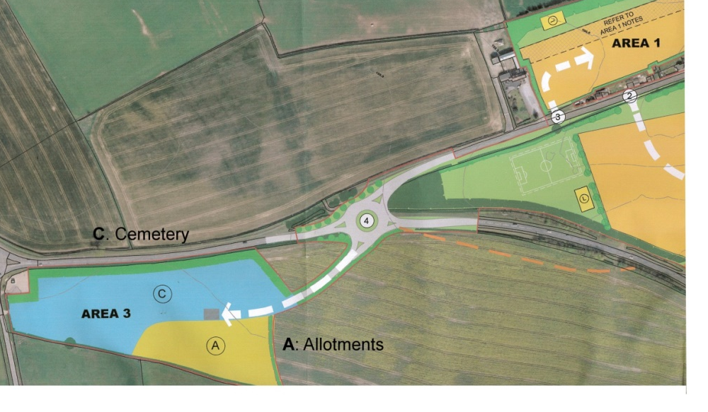
Currently the Town Council hopes to secure a new cemetery site (approx. 5.8 acres) within the next two years. Initial work in the form of environmental assessments has taken place which will allow an area next to the A421 to be used as a new cemetery.1.8 acres of the site would be left for a permanent allotment site however in the short to medium term a large % of the allocated cemetery could be used as allotments with the understanding in the long-term this will be required to be taken back for burial provision in the future. Additional facilities required. A multi-purpose building which would provide toilet facilities, Storage of burial machinery, equipment and a shelter from the elements for people attending funerals. Road/paths for circulation around the cemetery and access to the new allotments. Car Park, off road Parking provision for the cemetery. The Town Council is pursuing approval of the cemeteries’ planning application with assurance that the A421 roundabout is complete ahead of any construction on the Tingewick Road.
Traffic Noise from A421
“What can be done to reduce the traffic noise from the A421 into Lace Hill?”
Suggestions of acoustic barriers and noise reducing road surfaces will be feedback to the Developers and District Council. These measures have previously been suggested by the Town Council when we consulted on the planning applications for the both the Lace Hill residential and commercial developments.
“The Bletchley roundabout (A421) is in a poor state of repair”
The Town Council has reported this to the Highways Authority
“Gawcott Road – why not make it a no-through road at the top of the hill to prevent HGVs attempting to gain access to the town centre.”
Parking on the hill has become an issue since the road was resurfaced and residents are parking on the right.
Street lighting – Broken streetlights can be reported to Bucks County Council via the following portal https://www.buckscc.gov.uk/services/transport-and-roads/report-a-problem/report-a-broken-streetlight/

Increase in Buckingham’s Town Council Tax
“Why do we have an increase in our Precept this year?”
In 2018-19 the Buckingham Town Council budget will be increasing by £12.10 per year for a Council Tax Band D property to £159.49. This 7.59% increase is so that we can continue to provide the current services, as well as take on new services and facilities. We have created the following infographic to explain
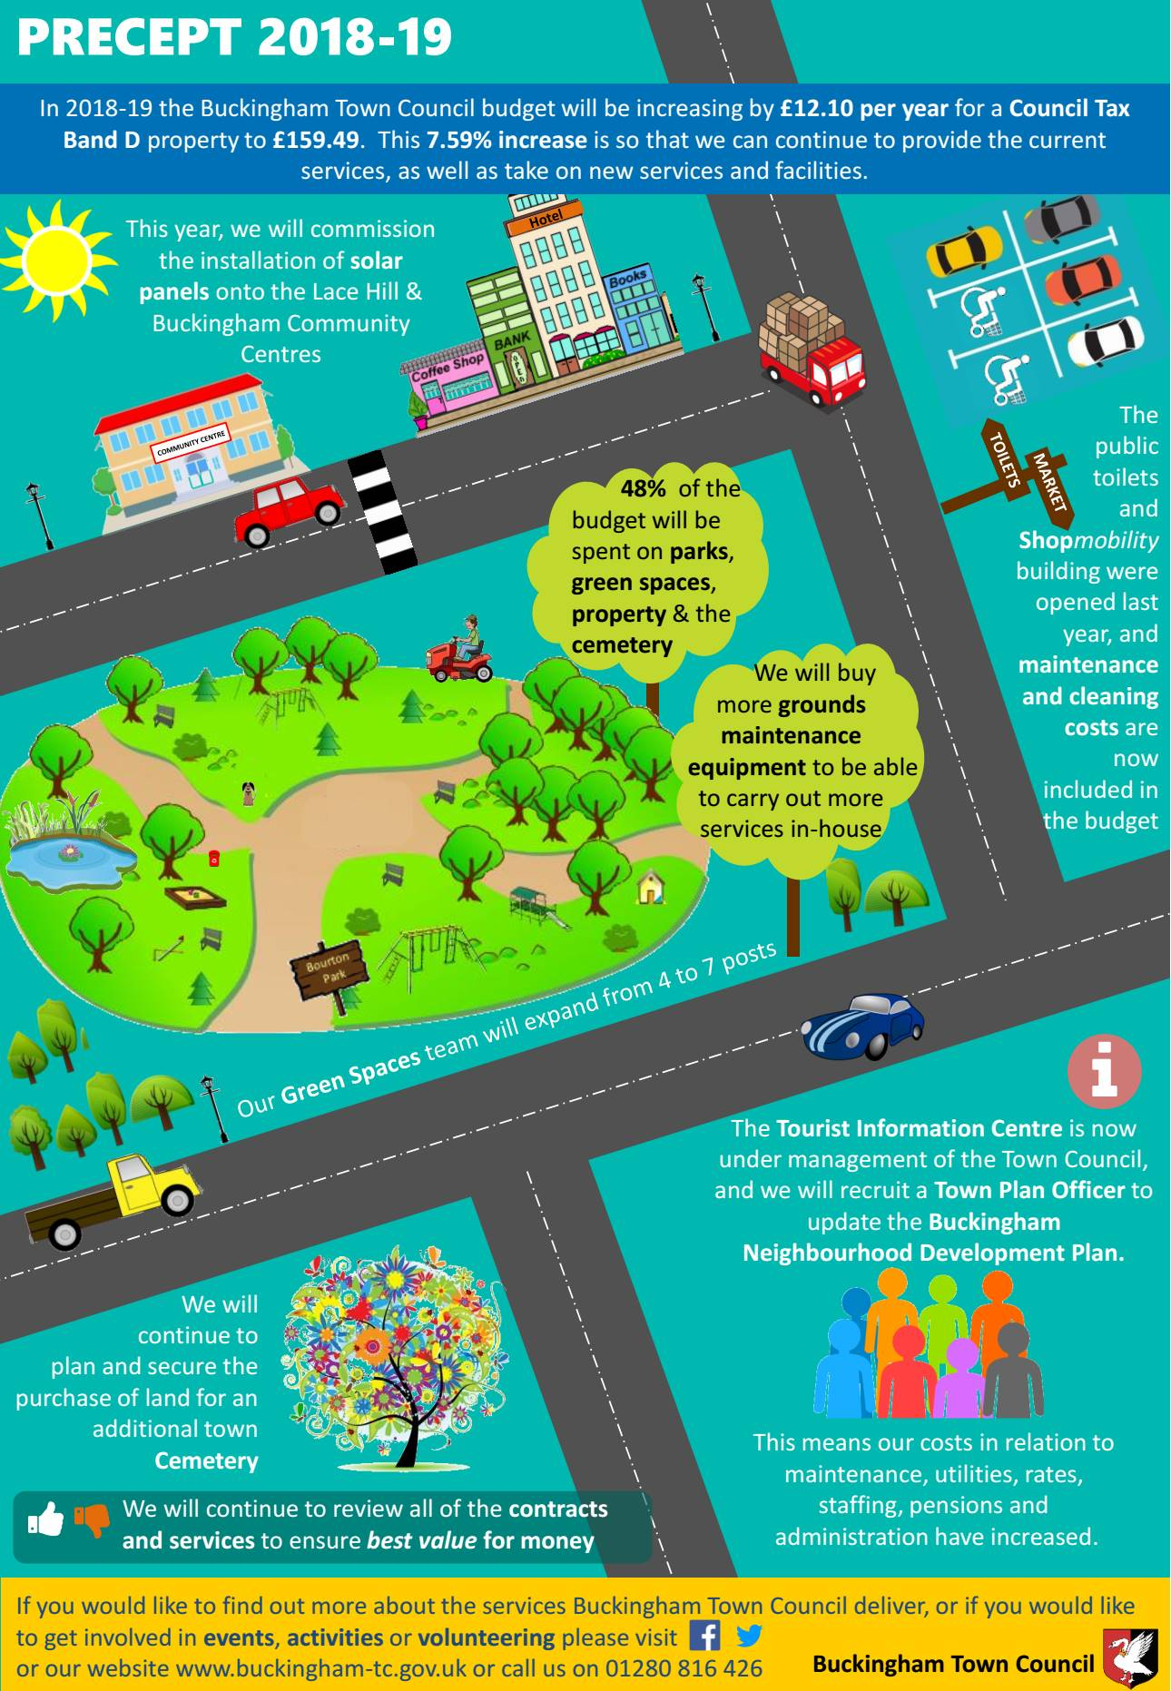
Tingewick Road Development
Access/Traffic during construction – is this to be enforced on routing and times of day
What is he Town Council’s view on the development?
No plans for supporting infrastructure- broadband etc.
Higher density than Lace Hill – have lessons been learnt?
What disruption is expected from the new roundabout at A421- who is responsible for maintaining it?
Please see the Town Council response to the planning application from the Interim meeting of Full Council 19th February 2018.
Land North Of A421 Tingewick Road Buckingham Buckinghamshire
Approval of the reserved matters details of the external appearance of the buildings, the landscaping of the site, layout and scale for each phase or part of the development together with discharge of conditions 2 (phasing) and 6 (design code) pursuant to outline permission 15/01218/AOP for consideration of means of access to provide up to 400 Residential Dwellings (including Affordable Housing), Open Space including Play Areas and sports and related recreation facilities, Landscaping, New Vehicular and Pedestrian Accesses, Engineering (including Ground Modelling) Works, Infrastructure Works (including Drainage Works and Utilities Provision) and Demolition (including Site Reclamation), Car Parking and Lighting.
Additional Plans & Documents listed on the website but not yet received (45)
- Design Code
- LEAP equipment (2)
- NEAP equipment
- Ecological Management Plan
- Arboricultural Report
- Hard Landscape proposals (16 sheets)
- Soft Landscape specification
- Soft Landscape Management Plan
- Soft Landscape proposals (18 sheets)
- Tree Protection Plan (2 sheets)
- Tree Report

The Planning Clerk had expanded the previous report on this application to include details of the Design Code document; this had been circulated with the agenda.

It was felt that little reference had been made to the Vision and Design Statement SPG; the design was monotonous, with uniformly coloured bricks and roofs. Buckingham had a variety of brick colours and slate and tile roofs and this estate would be the first sight of the town for travellers from the west, and should reflect the styles to be found in the town.

Members were against block paving for streets; it did not stand up to wear, was difficult to relay properly after roadworks, and would not be adopted. There was no guarantee that the 20mph speed limit would be implemented or enforced, and the block paving was stated not to be adequate for higher speeds; all roads should be built to adoptable standards. Criticism was also made of shared surface streets; experience at Lace Hill showed that these were unsafe, as people parked right up to walls and frontages, forcing pedestrians into the roadway. At the very least differently coloured tarmac could be used to mark off a footway. It was not clear from the document how ‘private drives’ were to be separated from continuation streets of another category; the one just inside the B access, which provided a much more direct route to the housing on the ‘green lane’ on the western perimeter, was of particular concern as it would be taking as much traffic as the other roads connecting with the access points without their strength of construction. If there was to be a physical barrier preventing this it should be stated, and reasons given.

None of the Affordable Housing had a garage and thus the social housing could be readily differentiated from the sale housing, contrary to the principle of tenure blindness. Pre-planning advice quoted had also discouraged the use of parking courts, yet this had been ignored. Garages should be wide enough to house and open the door on a modern car (generally over 2m wide including mirrors) or they would not be used, leading to on-street parking to the detriment of the general appearance of the street scene and the safety of residents.
There was no indication of how ‘allocated parking’ would be implemented; this could be a potential cause of conflict between residents.

The NEAP was too far from housing to ensure surveillance, leading to concerns about the safety of unaccompanied children.

The distance from the rear of some terrace houses to the street – for the hauling of bins for collection - was in some cases over 50m, well in excess of the guideline length, and might lead to bins being left at the front of the house, or being taken through the house itself.

Referring back to Lace Hill, where two points of access had been deemed necessary but only one was operational when the housing was largely occupied, it was asked that both accesses and the connecting road be constructed and available for use from the start of works.

A surfaced footpath from the estate via the St Rumbold’s Well area to the proposed foot/cycle path along the Scenic & Railway Walks was necessary so that children could walk dry-shod to school. The existing public footpath to Gawcott Road was not a convenient route to schools and involved unsafe sections on the way into town. The construction should acknowledge the likelihood of historic matter lying under the route chosen.

No landscaping should be done until the necessary archaeological work had been completed. Care would need to be taken over drainage of the site, as the current waterlogged conditions were beneficial to the preservation of organic remains.

The difficulties experienced by Highways in maintaining efficient drainage via the Tingewick Road culvert (not in Council ownership) and its capacity crossing the line of the railway were noted as a concern to be addressed in relation to the rate of outflow from the attenuation basins.

A broadband service to all homes should be available on occupation, not many months later, as at Lace Hill.
An Equality Impact Assessment was requested to measure disabled access and road safety in particular, but also suitability of housing for residents with special needs.

It was hoped that the bypass roundabout would be completed early to alleviate problems generated by the construction traffic.

Proposed by Cllr. Stuchbury, seconded by Cllr. Hirons and AGREED that the Town Clerk be allowed to enter discussions at the appropriate time about acquisition of the open spaces on the development. Members noted that the Lace Hill management company charges were noticeably higher than Town Council rates for similar work.
Proposed by Cllr. Smith, seconded by Cllr. Stuchbury, and AGREED that the Town Council make no formal response to this application until the documents listed above were received; however the above comments would be relayed to AVDC in order that the developer could consider Members’ concerns related to the Design Code documents.

Oxford to Cambridge East West Expressway
“What is the Town Council’s view on the development?”
Please see below the minutes from Planning Committee of the 19th March 2018:
Cllr. Cole informed Members that the VALP was submitted to Government on the 28th February 2018 and would be subject to examination by an independent planning inspector during the summer. It was anticipated that it could be approved by early 2019.
Oxford-Cambridge Expressway – Cllr Harvey reminded Members that the Town Council have always been in full support of the project and favoured a route option that brought the road as close to Buckingham as possible. Route option B (located between Winslow and Padbury) offers the best integrated transport options following the line of the East-West railway. Cllr. Cole reminded Members that 60,000 houses and associated infrastructure will be constructed along the chosen route and that currently AVDC were only considering routes A and B as viable options.

Proposed by Cllr Harvey and seconded by Cllr. O’Donoghue and RECOMMENDED to Full Council that the Town Council request that option B is chosen as the preferable route for the East-West Expressway.

A vote was taken and the results were:
In favour 6
Against 2
Abstentions 1
Motion carried

Community Snow Clearance
“Volunteers at weekends when the Town Council can not grit the town paths”
The Town Council will promote a scheme similar to Bucks County Council’s ‘be a good neighbour’ scheme, encouraging residents to help vulnerable neighbours clear their paths in poor weather.
“Why is Tingewick Road, Gawcott Hill and Mitre Street not gritted?”
Please find attached a link to how Bucks County Council decide which paths/routes to grit in poor weather:
https://www.buckscc.gov.uk/services/transport-and-roads/road-maintenance-and-repairs/how-we-decide-when-to-grit-the-roads/
The request to add Tingewick Road, Mitre Street and Gawcott Hill onto Highway’s gritting routes has been forwarded onto the appropriate authorities.
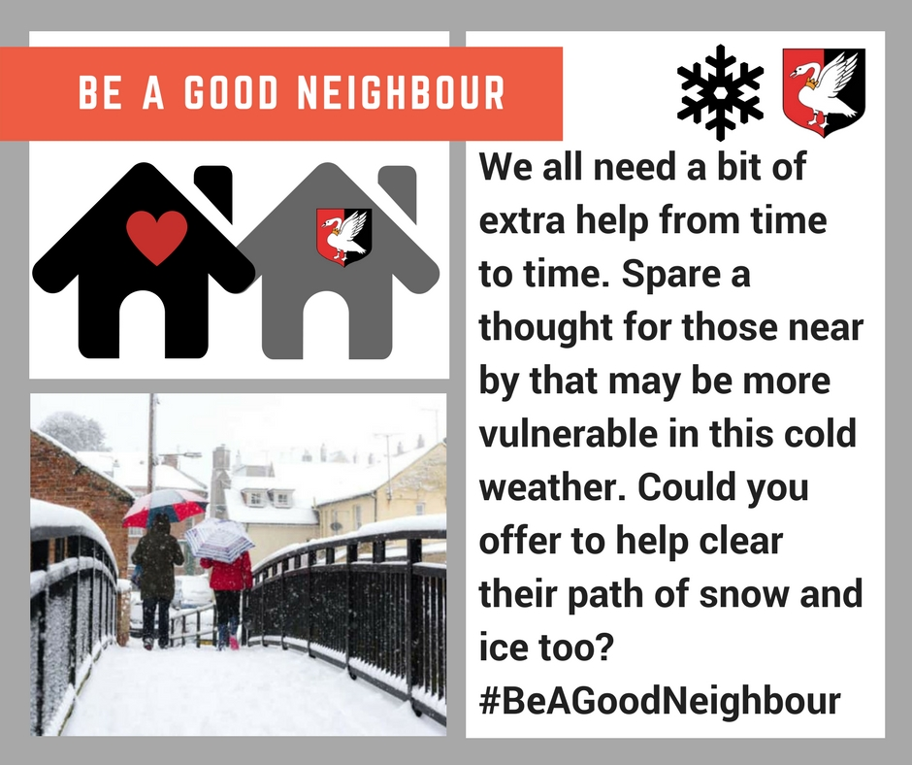

Buckingham University
“What discussions are happening with the Town Council?”
Please see the minutes from Full Council of the 12th March 2018:
Cllr. Harvey spoke of the University staff’s enthusiasm to make the partnership work. Cllr. O’Donoghue spoke in favour of the report recommendations thanking the Mayor for developing the opportunity. Cllr. Stuchbury called for a Terms of Reference to be established and for the Town Mayor to Chair the meetings.

An amendment to the report recommendation Proposed by Cllr. Stuchbury and seconded by Cllr O’Donoghue and unanimously AGREED “There are a number of projects that could emerge from this but I think in the very first instance and agreed by partners should be a terms of reference to form a joint planning team to work towards developing a place where there is even greater mutual respect, reverence and affection between the University and its staff, the student body, the townsfolk, local businesses and the Town Council. My recommendation is we establish such a small focused body to be jointly chaired by the Mayor and VC with Councillors, TC Officers, students, University staff and local traders representation. Such a group can act as action/results focused working party to make recommendation back to appropriate parts of the University and TC structures. ACTION TOWN MAYOR

Buckingham’s High Street
“More independent shops needed in town!”
Buckingham Town Council works with Shop Buckingham (Traders Association) and groups such as Destination Buckingham to promote the town and encourage people to shop, eat and stay in Buckingham. From our recent consultation it appear as those residents perception is that the High Street is decline due to high business rates (see below) and decreased footfall. We can all do our bit to promote and support the traders in our town encouraging more people to visit and use our shops and other facilities.
“More litter bins needed for school pupils on London Road”
There are currently four litter bins on London Road between Buckingham School and Sainsbury Local. However, there are only 2 between Buckingham School and the Tesco roundabout, one of which is located far from the footpath. Buckingham Town Council has written to AVDC requesting consideration for another litter bin in this location.
“Reduce business rates and make parking free in Cornwall Meadow”
Buckingham Town Council doesn't get much say in what businesses start up in the Town Centre that is normally between the landlord and the company. We have tried to use our limited powers in the Neighbourhood Plan to require 35% retail in the primary shop frontages. The Town Council has long been advocates for free point of use parking in the Town Centre and in fact before the charges first came in 8 years ago was paying £27,000 a year to keep it free. AVDC would now require us to put the Town Council's element of the Council tax up by £32.20 to enable parking to be free.

Pot holes
“The quality of repair work is low – is this audited by County?”
“Who decides what is repaired and when?”
The maintenance of roads is the responsibility of the Highways Authority and our Planning Committee regularly report dangerous pot holes to the County Council. We strongly advocate the use of their reporting tool – link here:
https://www.buckscc.gov.uk/services/transport-and-roads/report-a-problem/report-a-pothole/
Town Diary
“Publicise the use of the Town Diary”
The Tourist information Centre is now under the management of Buckingham Town Council and we have successfully appointed a full time Supervisor. One of the Supervisors duties will be to coordinate the Town Diary and promote events in the local area.
Town Centre Parking
More informative Council website – shopping
We do not feel the Council’s website should be used to advertise private businesses but agree that we could add a section describing the types of shopping to be found within our arcades and Hidden Quarter.
Better signage to The Hidden Quarter
Buckingham Town Council has been working with Destination Buckingham to update the metal signposts throughout town and will be adding finger posts directing shoppers to the Hidden Quarter.
Making the most of open days and event at University/Silverstone and Stowe.
Our Tourist Information Centre staff share local events publicity to ensure that Buckingham is always seen as a destination associated with larger local events. In the future we would like to host stands at the University’s open days to further publicise everything our town has to offer to our new students and their families.
Farmers Market/Artisan Market and Food Fair
We already host an annual Food Fair in the Buckingham Community Centre and support the Trader Association in previous food markets at the Christmas Light switch on.
Reinstate the identity of our historic town offering tours?
This is a lovely idea and something we have previously discussed at the Tourist information Centre. We have not had any requests to run walking tours but this could be something to further investigate especially around larger events at the University and Silverstone.
Why is car parking free in Winslow and not Buckingham?
We understand the Winslow Town Council owns the car park and not the District Council.

Format of the Virtual Annual Town Meeting
We feel that the virtual ATM enabled the Town Council to engage with a wider audience that ever before and great a forum for residents to discuss local issues. The Town Council posed the following three questions for discussion:
Following the recent closure of Clays and NatWest, what ideas or initiatives would you suggest to attract more people to our High Street?

Residents’ Comments | No. similar comments | Town Clerk’s comments
Free Parking in Cornwall Meadow and more spaces across town | 31 | Yellow lines and on street parking have just been reviewed by the County Council. The Town Council have long been advocates for free point of use parking in the Town Centre and in fact before the charges first came in 8 years ago were paying £27,000 a year to keep it free. AVDC would now require us to put the Town Council's element of the Council tax up by £32.20 to enable parking to be free.
A greater variety of shops in Buckingham | 77 | The Town Council doesn't get much say in what businesses start up in the Town Centre that is normally between the landlord and the company. We have tried to use out limited powers in the Neighbourhood Plan to require 35% retail in the primary shop frontages.
A shared community workspace | 1 | There is already such a place in town. It is based in the Old Town Hall and is run by Villiers. Jean Rush can help
Reduce business rates | 10 | Rates do appear to be a big issue. Town Council doesn't levy the Business rates, nor does it receive any of the income from them. The Town Council don't have a say over the business rates, for information on how they are calculated please see https://www.aylesburyvaledc.gov.uk/section/business-rates
Electric car points | 1 | This is something the Town Council have asked for before. We tried to include it with the Neighbourhood Plan but AVDC didn't want us to.
Replicate successful markets in other towns | 2 | We are continually looking at ways to review and improve our Street Market and have started publicising across social media raising the profile of our market and resulting in a number of new traders.
Reinvigorate the Traders Association and encourage people to shop locally | 11 | Buckingham Town Council is hoping to present some new initiatives at the next meeting of the Traders Association and will continue to publicise and promote via Discover Buckingham.
Pedestrianise the High Street | 7 | High rents and rates does appear to be a problem. There has been talk previously about pedestrinisation of the town centre. The concerns raise previous was the amount disruption of travelling from one side of town to the other. Do you think this is a big problem? or do you have a solution that might not have been thought of?
Nostalgic comments | 20 | We are glad the forum enabled residents to share their memories of Buckingham.

The Future – Proposed changes to Local Authority could mean that Buckingham Town Council has the opportunity to take ownership of some services currently run by AVDC and Bucks County Council. Which services would you like to see run by your Town Council in the future?

Comments | No. similar comments | Town Clerk’s comments
Everything! | 5 | The Town Council will take on board residents’ comment when responding the Government Minister’s decision on the future of Local Government in Buckinghamshire.
Planning | 1
Rivers | 1
Registrars | 1

Following the recent interest in Otters - what would you like to see replace the wooden Otter sculptures in Bourton Park, and how could this be funded?
Comments | No. similar comments | Town Clerk’s comments
Replace with similar sculptures | 71 | The largest Otter had to be removed. It hadn't been treated properly when we took over maintenance of the park. As a result it continued to deteriorate and in the end needed to be removed. One option would be to keep the two existing but again they were not treated with the proper finish to protect them for longer so will eventually need to be replaced.

Recommendation: Members agree a statement to respond to the most popular subjects discussed during the two Annual Town Meetings:
Replace the wooden Otters in Burton Park with a similar sculpture.
Following the Bourton Park Survey and Virtual Annual Town Meeting there appears to be significant public interest in seeing the Otter sculptures replaced and improving the amenity value of the pond system in Bourton Park. Two local artists expressed interest in commissioning replacement Otter sculptures and at Environment Committee on the 5th April 2018 Members agreed to commission replacement sculptures from ‘company B’ funded from the Parks Maintenance budget.
Buckingham Town Council to attract a greater variety of shops to the High Street.
The Town Council does not have any influence in what businesses start up in the Town Centre that is normally an agreement between the landlord and the company. We have tried to use our limited powers in the Neighbourhood Plan to require 35% retail in the primary shop frontages. We are currently in the process of reviewing our Neighbourhood Plan and will take on board residents’ comments when forming our consultation.
Free Parking in Cornwall Meadow and more spaces across the town
The Town Council have long been advocates for free point of use parking in the Town Centre and in fact before the charges first came in 8 years ago were paying £27,000 a year to keep it free. AVDC would now require us to put the Town Council's element of the Council tax up by £32.20 to enable parking to be free, which we do not believe to be in the best interest of the town. We are investigating funding option to build tiered parking on the Cornwalls Meadow car park. This could be a partial tier, protecting the pleasant views toward Heartlands and boosting the amenity value of the site by creating a small river side area for shops and cafes.

