
Friday, 31 July 2026
Councillor,

You are summoned to an Interim meeting of the Full Council of Buckingham Town Council to be held on Monday 1st November 2021 at 7pm in the Council Chamber, Cornwalls Meadow, Buckingham.

Please note that the meeting will be preceded by a Public Session in accordance with Standing Orders 3.e and 3.f, which will last for a maximum of 15 minutes. Members of the public can attend the meeting in person. The Council is trialling the use of video conferencing to enable the public and guests to address Council meetings virtually. If you would like to address the meeting in this way, please email committeeclerk@buckingham-tc.gov.uk or call 01280 816426 for details.

The meeting can be watched live on the Town Council’s YouTube channel here: https://www.youtube.com/channel/UC89BUTwVpjAOEIdSlfcZC9Q/

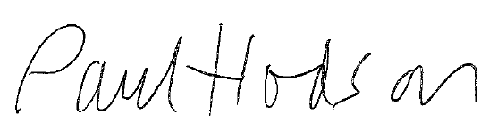

AGENDA

Apologies for Absence
Members are asked to receive apologies from members.

Declarations of Interest
To receive declarations of any personal or prejudicial interest under consideration on this agenda in accordance with the Localism Act 2011 Sections 26-34 & Schedule 4.

- Motion – Cllr. Stuchbury
In light of the fact that the Buckingham River Ouse was polluted with raw sewage in 2017 Buckingham Town Council as a riparian owner of large stretches of the river through the town of Buckingham - disagrees with allowing sewage to be dumped into the river course and therefore registers its concern and objections to the Government’s decision not to adopt the stronger measures proposed in the Environment Bill to restrict the discharge of raw sewage into our water courses, allowing water companies to continue the dumping of sewage within our river. The river is used by members of our community for leisure and recreation throughout the year. The Council therefore agrees to write to the Secretary of State for Environment, Food and Rural Affairs registering our concern and asking them to seek to support legislation that restricts the discharge of raw sewage into our rivers at the earliest appropriate opportunity.

- Remembrance Sunday Screen
TC&E Committee min 433.2/21
It is recommended that the Committee recommend to Interim Council that up to £2,000 be taken from the contingencies budget (132 4500) to hire a large mobile screen to show the Remembrance Sunday Service on the Church Green for those who are unable to see the event around the Memorial. TCE/57/21
NB: Updated costs for hire of a large screen £1,687

- Friends of Buckingham University Group
To receive and agree nominations to act as the Town Council’s representative on the Friends of Buckingham University Group

Lace Hill Medical Centre Consultation
To receive a proposed response from the Town Council’s Working Group
To be circulated

Chairman’s Announcements

Date of next Meetings:
Full Council Monday 22nd November 2021
Interim Council Monday 20th December 2021

To: All Councillors

